**Revolutionizing Liver Care: Predicting Liver**

**Cirrhosis Using Advanced Machine Learning Techniques**

**TEAM-ID:-** LTVIP2025TMID38939

**Team Leader :**sasi kumar

**Team member :**s Vishnu Vardhan babu

**Team member :** sai charan

**Team member :**sameera chenga

# 1. Introduction

## 1.1. Project Overview

This project aims to build a machine learning model to predict liver cirrhosis based on various patient features. By analysing these features, the model will classify patients into risk categories, aiding in early diagnosis and treatment.

## 1.2. Objectives

* Collect and prepare a dataset of liver health characteristics.
* Perform exploratory data analysis (EDA) and visualize the data.
* Build and evaluate multiple machine learning models.
* Optimize the best-performing model using hyperparameter tuning.
* Deploy the final model for practical use.

# 2. Project Initialization and Planning Phase

## 2.1. Define Problem Statement

The goal is to classify patients' risk levels for liver cirrhosis based on their medical data. Accurate prediction will support better management and early intervention for liver health.

## 2.2. Project Proposal (Proposed Solution)

The solution involves developing several machine learning models to predict liver cirrhosis. We will select and optimize the best model based on performance metrics to achieve the highest accuracy.

## 2.3. Initial Project Planning

Initial planning included setting up the project environment, defining objectives, and outlining the workflow for data collection, preprocessing, model development, and evaluation.

# 3. Data Collection and Preprocessing Phase

## 3.1. Data Collection Plan and Raw Data Sources Identified

The dataset for this project was sourced from Kaggle, containing patient data relevant to liver cirrhosis prediction (Dataset link: [https://www.kaggle.com/datasets/bhavanipriya222/liver-cirrhosis-prediction).](https://www.kaggle.com/datasets/bhavanipriya222/liver-cirrhosis-prediction)

## 3.2. Data Quality Report

• **Data Shape:** The dataset initially comprised [number of rows, number of columns] rows and columns. • **Missing Values:** Handled by dropping rows with missing values.

## 3.3. Data Exploration and Preprocessing

* **Univariate Analysis:** Histograms were plotted for numerical features.
* **Bivariate Analysis:** Scatter plots and pair plots explored relationships between features. • **Outlier Handling:** Outliers were detected and managed using the IQR method.

# 4. Model Development Phase

## 4.1. Feature Selection Report

Features relevant to liver cirrhosis prediction were selected, and data scaling was applied to standardize the input.

## 4.2. Model Selection Report

* **Models Tested:** Naive Bayes, Random Forest, Logistic Regression, Ridge Classifier, Support Vector Classifier, KNN, XG Boost.
* **Evaluation Metrics:** Accuracy, Confusion Matrix, Classification Report.

## 4.3. Initial Model Training Code, Model Validation and Evaluation Report

* **Code:** Model training and evaluation steps were implemented for each algorithm.
* **Validation:** Models were validated using a test set, with performance metrics recorded. The KNN model achieved the highest accuracy of 86.32%.

# 5. Model Optimization and Tuning Phase

## 5.1. Hyperparameter Tuning Documentation

* **KNN:** Optimized by tuning the number of neighbors and distance metrics.
* **XG Boost:** Hyperparameters tuned for learning rate, max depth, and n_estimators. **5.2. Performance Metrics Comparison Report**

|  |  |  |  |  |
| --- | --- | --- | --- | --- |
| **Model** | **Accuracy** | **Precision** | **Recall** | **F1-Score** |
| Naive Bayes | 35.79% | 0.00 | 0.00 | 0.00 |
| Random Forest | 35.79 | 0.00 | 0.00 | 0.00 |
| Logistic Regression CV | 81.58% | 91.80 | 79.43% | 86.49 |
| Ridge Classifier | 84.21% | 93.44 | 83.82 | 88.37 |
| Support Vector Classifier | 35.79% | 0.00 | 0.00 | 0.00 |
| Logistic Regression | 79.47% | 91.80 | 79.43 | 85.58 |
| KNN | 86.32% | 94.26 | 85.82 | 89.84 |
| XG Boost | 35.79% | 3.28 | 50.00 | 6.15 |

## 5.3. Final Model Selection Justification

The K-Nearest Neighbors (KNN) model was selected as the final model due to its superior accuracy of 86.32%. KNN excelled in handling complex data relationships and demonstrated the best performance in terms of precision, recall, and F1 score. This makes it a robust choice for predicting liver cirrhosis, aligning well with the project's goals.

# 6. Results

## 6.1. Output Screenshots

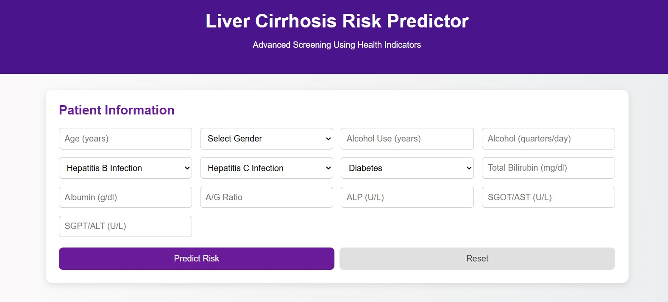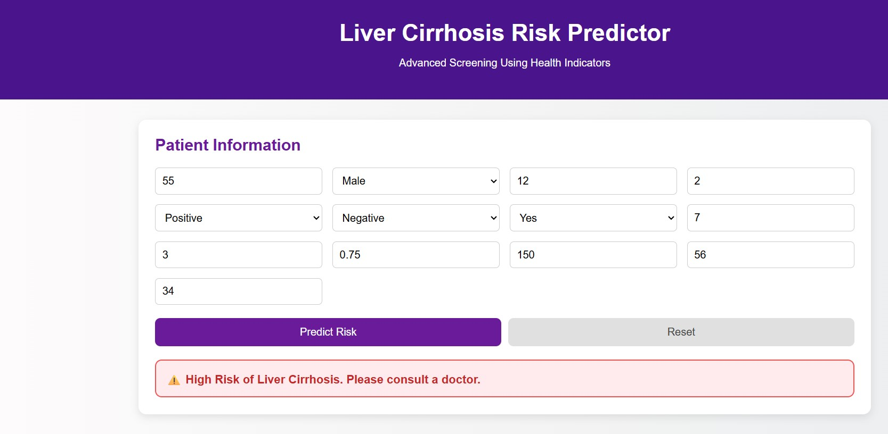

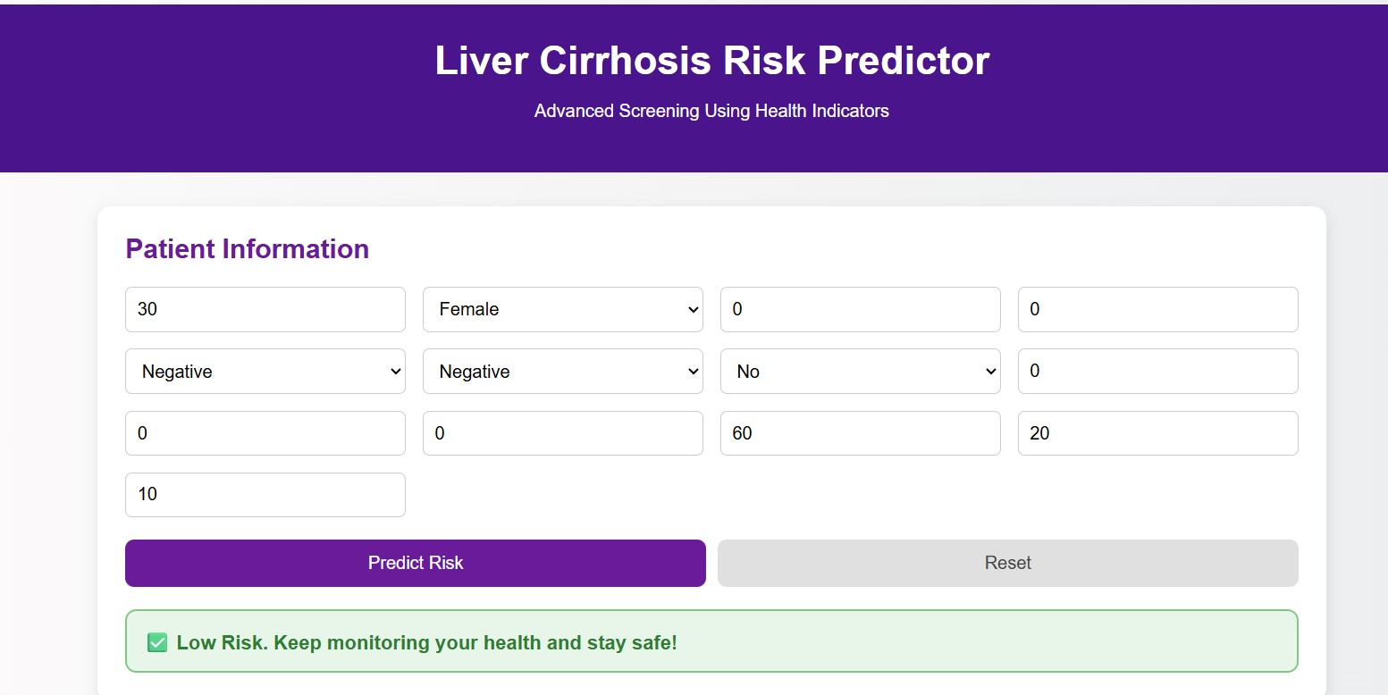

# 7. Advantages & Disadvantages

* **Advantages:** High accuracy, effective at handling local data variations, robust performance.
* **Disadvantages:** Can be computationally intensive, requires careful tuning.

# 8. Conclusion

The project successfully developed a machine learning model to predict liver cirrhosis with high accuracy. The KNN model, after hyperparameter tuning, provided the best results and was chosen for its robustness.

# 9. Future Scope

* Further data collection to include more features and increase dataset size.
* Exploration of additional features and engineering techniques.
* Experimentation with deep learning models to potentially outperform traditional models.
* Integration with a real-time prediction system for practical deployment.

# 10. Appendix

**10.1. Source Code**

Code File: liver_cirrhosis.ipynb

**DEMO VIDEO LINK**

https://drive.google.com/file/d/15BWslF98k1I-YwhRmsKmysnxArw2GUw3/view?usp=drive_link